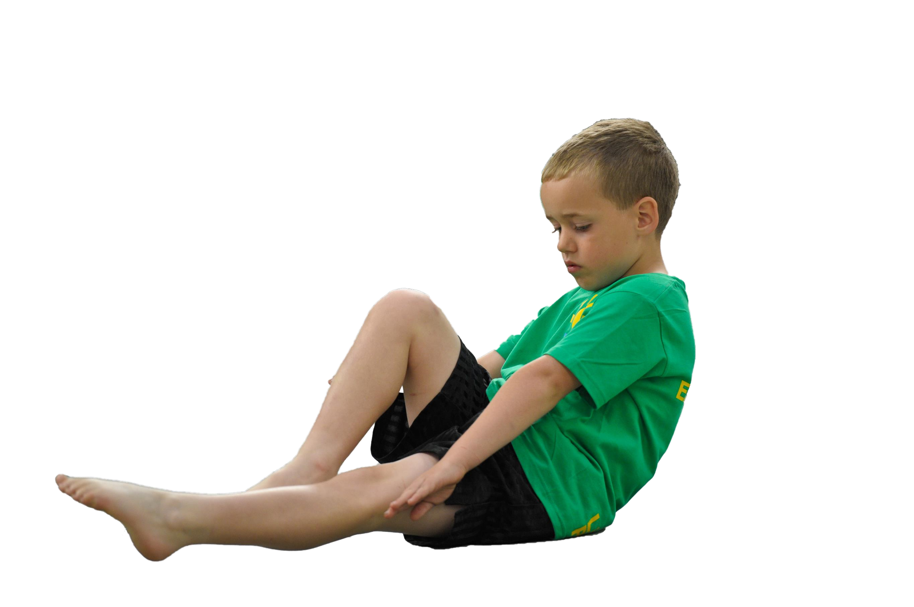**Ursuline Catholic Primary School**

# Sports Premium Statement 2023-24



**Support for review and reflection - considering the 5 key indicators from DfE, what development needs are a priority for your setting and your students now and why? Use the space below to reflect on previous spend, identify current need and priorities for the future.**

|  |  |
| --- | --- |
| **Key achievements to date:** | **Areas for further improvement and baseline evidence of need:** |
| * Introduction of OAA, Fundamental Movement Skills and Dance into our school curriculum. * Implementation of new PE software, PE Passport. * Success in inter-school sports. (Football, Cross Country, Dodgeball, Multisports). * Widened extra-curricular offer using pupil voice to carefully select clubs. * New format for breaktime and lunchtime football introduced using a 4v4 format. * School social media platforms are providing parents with updates on sporting achievements and helping to raise the profile of PE in school. * Annual Y6 Residential Visit promotes resilience and teamwork. * Outdoor and indoor multi-sports courts maintained for consistent use. * Links with Feeder High Schools such as Chesterfield, Sacred Heart and Merchant Taylors. | * Continue to identify CPD opportunities for Sports Apprentice. * Continue to monitor use of PE Passport software to evidence and collect data. * Explore further sports for reluctant pupils and those who do not get to represent the school in team events * Look to implement ‘Intra-School’ competitive sport into existing PE offer. * Continue to remain competitive in inter school sport fixtures/ tournaments. * Improve teachers’ PE teaching through correct explanation of skills and the correct use of vocabulary through observations of excellent teaching practice. * Explore further opportunities for Outdoor Learning (LOTC) through Beach School and Crosby Marina & Lakeside. * Widen our current extra-curricular club offer using pupil voice. * Create a wealth of opportunities to contribute towards cultural capital. * Monitor existing extra-curricular club offer to ensure all year groups have equal experiences. * Use PE data to identify and target our 20% least active children. * Continue to monitor social media to help raise the profile of PE in school. * Incorporate more lunch time activities by planning for lunchtime staff to lead activities in designated areas. |

|  |  |
| --- | --- |
| **Meeting national curriculum requirements for swimming and water safety** | **Please complete all of the below:** |
| What percentage of your current Year 6 cohort swim competently, confidently and proficiently over a distance of at least 25 metres?  **N.B.** Even though your children may swim in another year please report on their attainment on leaving primary school. | Data Available at the end of Aut 2. |
| What percentage of your current Year 6 cohort use a range of strokes effectively [for example, front crawl, backstroke and breaststroke]? | As above |
| What percentage of your current Year 6 cohort perform safe self-rescue in different water-based situations? | As above |
| Schools can choose to use the Primary PE and Sport Premium to provide additional provision for swimming but this must be for activity **over and above** the national curriculum requirements. Have you used it in this way? | No. |

**Action Plan and Budget Tracking**

Capture your intended annual spend against the 5 key indicators. Clarify the success criteria and evidence of impact that you intend to measure to evaluate for students today and for the future.

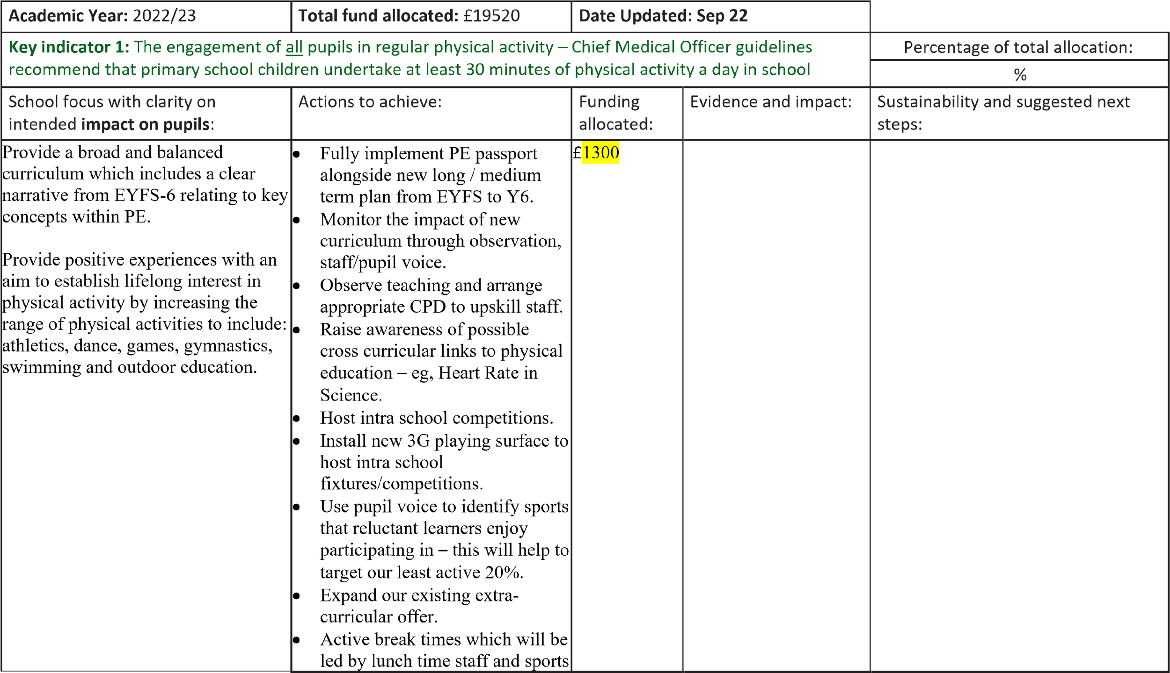

|  |  |  |  |  |  |
| --- | --- | --- | --- | --- | --- |
|  | coach. This includes use of the activity markings on the playground and our outside play equipment. |  | |  |  |
| **Key indicator 2: The profile of PE and School Sport being raised across the school as a tool for whole school improvement** | | | | | Percentage of total allocation: |
| % |
| School focus with clarity on intended **impact on pupils**: | Actions to achieve: | Funding allocated: | | Evidence and impact: | Sustainability and suggested next steps: |
| The integration of PE and sport into a curriculum which gives all pupils the knowledge and cultural capital they need to succeed in life. | * Create stronger links between PE and other curriculum areas to deepen understanding. For example: Dance to tie in with   History/Geography units.  Outdoor Adventurous Activities ties with fieldwork, Geography.   * PE / Olympics 2024 Paris school project to promote and raise the profile of competitive sport in school. * Teachers will teach and model how to lead simple activities to encourage participation. * Mini London Marathon completed by each child to encourage active lifestyles and raise money. | £3500 |  |  |  |
|  |

|  |  |  |  |
| --- | --- | --- | --- |
|  |  |  |  |

|  |  |  |  |  |  |  |
| --- | --- | --- | --- | --- | --- | --- |
| **Key indicator 3:** Increased confidence, knowledge and skills of all staff in teaching PE and sport | | | | | | Percentage of total allocation: |
| % |
| School focus with clarity on intended **impact on pupils**: | Actions to achieve: | Funding allocated: | | | Evidence and impact: | Sustainability and suggested next steps: |
| * Provide staff with professional development, mentoring, training and resources to help them teach PE and Dance provision effectively thus improving teaching and learning and outcomes for pupils.      * Ensure that all staff have a diverse knowledge of different PE topics and can confidently deliver a wealth of age-related activities to their class to further improve the quality of teaching and learning.      * Provide staff with access to PE passport, our curricula monitoring system for PE | * Teachers to lead both PE lessons each week. * Teachers to follow PE passport to ensure a challenging, progressive approach to planning and delivery. * Identify areas for required CPD and arrange appropriate training. * Arrange for staff members to observe excellent teaching practice within PE. Dance has been watched by teachers as one of our teachers is a dance teacher so has passed on her knowledge. * Teachers to use consistent use of key vocabulary through lessons * Teachers provide summative assessment through our PE passport system. This is to be quality assured by subject lead and SLT. * Introduce retrieval activity focusing on vocabulary for the start of each PE session, as seen in other areas of our curriculum. * Liverpool Football Club and Lancashire County Cricket Club to work with year groups to demonstrate excellent teaching and team teach alongside teachers to allow for effective CPD. |  | |  |  |  |
| £2145 |  |
|  |

|  |  |  |  |  |  |  |  |
| --- | --- | --- | --- | --- | --- | --- | --- |
| **Key indicator 4:** Broader experience of a range of sports and activities offered to all pupils | | | | | |  | Percentage of total allocation: |
| % |
| School focus with clarity on intended **impact on pupils:** | | Actions to achieve: | | Funding allocated: | | Evidence and impact: | Sustainability and suggested next steps: |
| * Preparation for and participation in various organised sporting events across Crosby and wider areas. * Increase the competitiveness and range of sports/skills in our Annual Sports Day * Termly Intra-School competitions (half days-afternoons) * Children have access to a range of non traditional after school clubs | | * Consult with pupils, staff and parents to identify activities and sports that will engage and motivate pupils. * Buy equipment to increase the range of provision provided. * Target the least active children within school by carefully selecting appropriate activities to encourage participation. * Create stronger link with Chesterfield High School through their weekly school competitions. * Enrich education- £4000 spent on brand new bespoke orienteering route and Quidditch equipment bought to introduce into school. * Fencing and Curling days booked in for KS2. * Circus skills day booked in for reception and KS1. * Quidditch days were enjoyed by every child in the school from reception to year 6. * Military school to continue to work with year 4-6 for one term per year. Residential for year 6 and sports day for KS2 ran by them as well. | | £10000 |  |  |  |
|  |
| **Key indicator 5:** Increased participation in competitive sport | | | | | |  | Percentage of total allocation: |
| % |
| School focus with clarity on intended **impact on pupils**: | | Actions to achieve: | | Funding allocated: | | Evidence and impact: | Sustainability and suggested next steps: |
| •  • | Access to a broad range of competitive sports for reluctant pupils and those not selected for school teams  Further success in inter school competitive sport | •  •  •  •  •  •  • | Broader range of sports/equipment available for children during break/lunch times  Introduction of small competitions in PE lessons for all areas of the curriculum.  Teachers encouraged to provide many  sporting opportunities through  PE/PSHE & Wellbeing  Participate in Crosby & District competitions.  Identify and remove barriers that prevent children from attending after school clubs.  Use midday staff to organise mini games during lunch times to maximise opportunities to practice skills in competitive situations. | £500 |  |  |  |
|  |