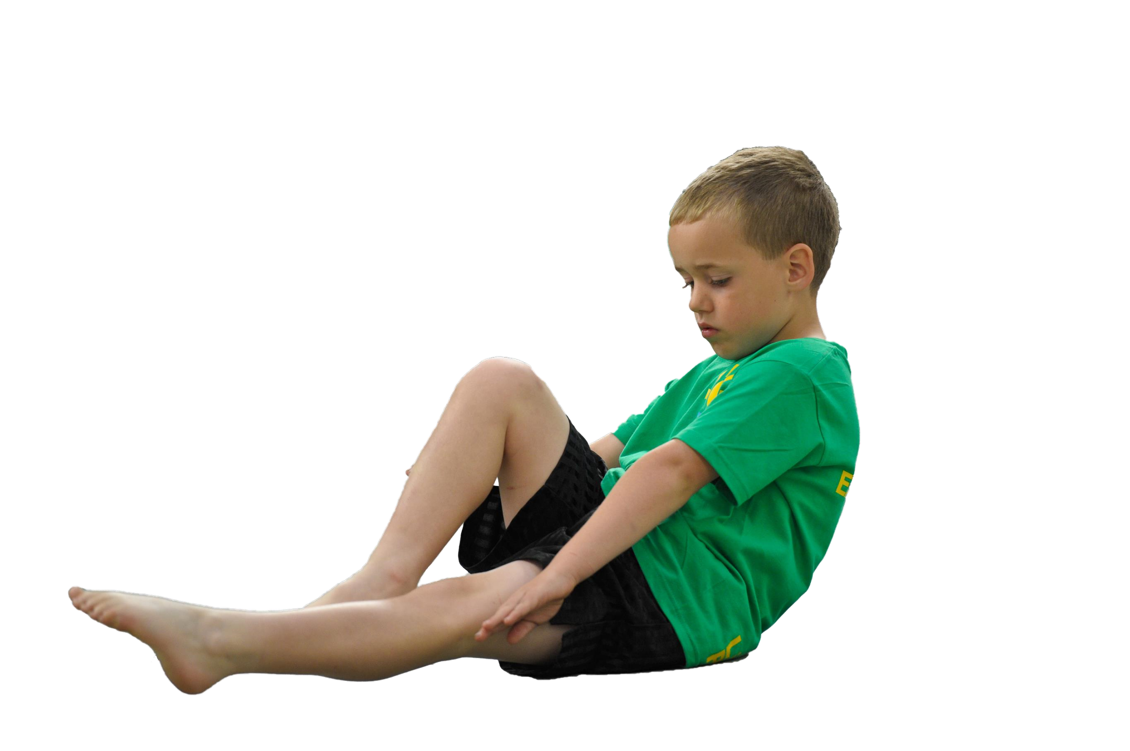**Ursuline Catholic Primary School**

# Sports Premium Statement 2023-24



**Support for review and reflection - considering the 5 key indicators from DfE, what development needs are a priority for your setting and your students now and why? Use the space below to reflect on previous spend, identify current need and priorities for the future.**

|  |  |
| --- | --- |
| **Key achievements to date:** | **Areas for further improvement and baseline evidence of need:** |
| * Introduction of OAA, Fundamental Movement Skills and Dance into our school curriculum. * Implementation of new PE software, PE Passport. * Success in inter-school sports. (Football, Cross Country, Dodgeball, Multisports). * Widened extra-curricular offer using pupil voice to carefully select clubs. * New format for breaktime and lunchtime football introduced using a 4v4 format. * School social media platforms are providing parents with updates on sporting achievements and helping to raise the profile of PE in school. * Annual Y6 Residential Visit promotes resilience and teamwork. * Outdoor and indoor multi-sports courts maintained for consistent use. * Links with Feeder High Schools such as Chesterfield, Sacred Heart and Merchant Taylors. | * Continue to identify CPD opportunities for Sports Apprentice. * Continue to monitor use of PE Passport software to evidence and collect data. * Explore further sports for reluctant pupils and those who do not get to represent the school in team events * Look to implement ‘Intra-School’ competitive sport into existing PE offer. * Continue to remain competitive in inter school sport fixtures/ tournaments. * Improve teachers’ PE teaching through correct explanation of skills and the correct use of vocabulary through observations of excellent teaching practice. * Explore further opportunities for Outdoor Learning (LOTC) through Beach School and Crosby Marina & Lakeside. * Widen our current extra-curricular club offer using pupil voice. * Create a wealth of opportunities to contribute towards cultural capital. * Monitor existing extra-curricular club offer to ensure all year groups have equal experiences. * Use PE data to identify and target our 20% least active children. * Continue to monitor social media to help raise the profile of PE in school. * Incorporate more lunch time activities by planning for lunchtime staff to lead activities in designated areas. |

|  |  |
| --- | --- |
| **Meeting national curriculum requirements for swimming and water safety** | **Please complete all of the below:** |
| What percentage of your current Year 6 cohort swim competently, confidently and proficiently over a distance of at least 25 metres?  **N.B.** Even though your children may swim in another year please report on their attainment on leaving primary school. | Data Available at the end of Aut 2. |
| What percentage of your current Year 6 cohort use a range of strokes effectively [for example, front crawl, backstroke and breaststroke]? | As above |
| What percentage of your current Year 6 cohort perform safe self-rescue in different water-based situations? | As above |
| Schools can choose to use the Primary PE and Sport Premium to provide additional provision for swimming but this must be for activity **over and above** the national curriculum requirements. Have you used it in this way? | No. |

**Action Plan and Budget Tracking**

Capture your intended annual spend against the 5 key indicators. Clarify the success criteria and evidence of impact that you intend to measure to evaluate for students today and for the future.

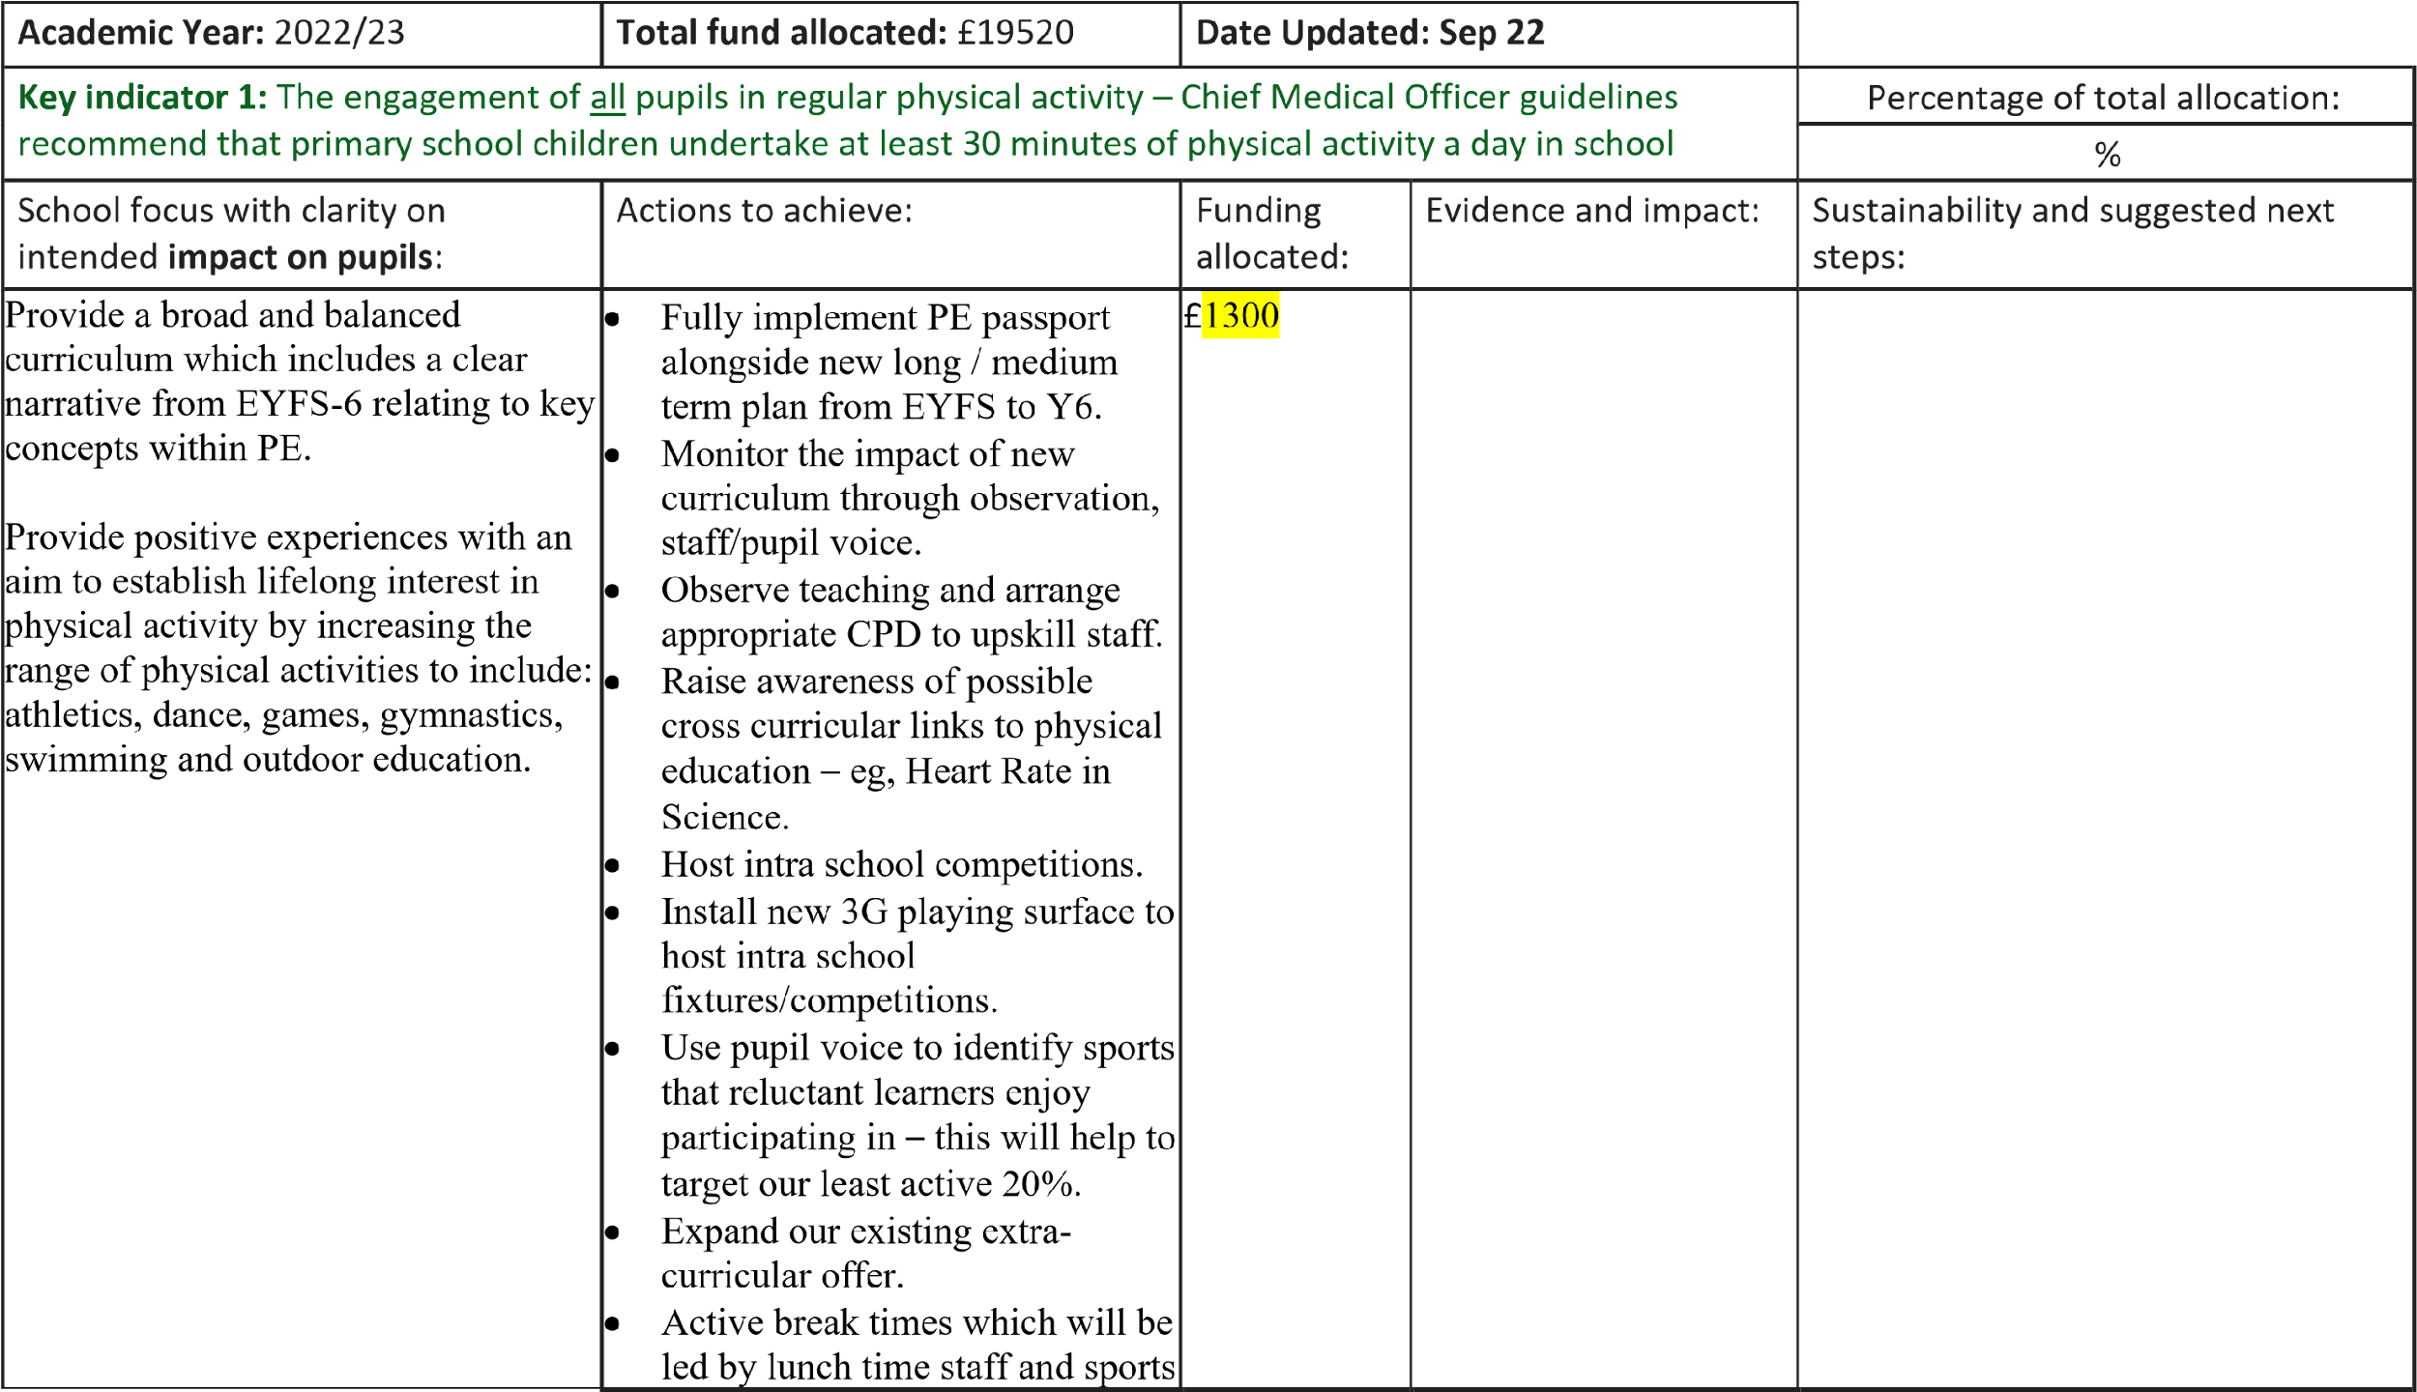

|  |  |  |  |  |  |
| --- | --- | --- | --- | --- | --- |
|  | coach. This includes use of the activity markings on the playground and our outside play equipment. |  | | Our new curriculum with gymnastics, dance and games has allowed all children to flourish at some point across the year whilst making sure they have room for development in other areas. Active break times have seen physical activity and fitness boosted as well as our wide range of extra curricular activity for the children. | Maintain links with other schools to play games against them.  Increase amount of physical activity through lessons (orienteering route)  Further enhance pupil voice to ensure we are hitting the needs of as many pupils as we can.  CPD to continue to upskill teachers. |
| **Key indicator 2: The profile of PE and School Sport being raised across the school as a tool for whole school improvement** | | | | | Percentage of total allocation: |
| % |
| School focus with clarity on intended **impact on pupils**: | Actions to achieve: | Funding allocated: | | Evidence and impact: | Sustainability and suggested next steps: |
| The integration of PE and sport into a curriculum which gives all pupils the knowledge and cultural capital they need to succeed in life. | * Create stronger links between PE and other curriculum areas to deepen understanding. For example: Dance to tie in with   History/Geography units.  Outdoor Adventurous Activities ties with fieldwork, Geography.   * PE / Olympics 2024 Paris school project to promote and raise the profile of competitive sport in school. * Teachers will teach and model how to lead simple activities to encourage participation. * Mini London Marathon completed by each child to encourage active lifestyles and raise money. | £3500 |  | We have seen a greater level of skill shown in KS1 since our change to our reception PE curriculum where they focus on fundamental skills to then apply into small games as they progress in year 1 and 2 ready for KS2.  Whole school PE events such as the Olympics 2024 and our own Euro 2024 tournament fostered a whole school active approach and led to many children beginning physical activity. | Next steps will be to maintain this and ensure we are doing a whole school event once a year as well as encouraging intra year competition at the end of a unit to allow for more children to participate and apply their skills. |
|  |

|  |  |  |  |
| --- | --- | --- | --- |
|  |  |  |  |

|  |  |  |  |  |  |  |
| --- | --- | --- | --- | --- | --- | --- |
| **Key indicator 3:** Increased confidence, knowledge and skills of all staff in teaching PE and sport | | | | | | Percentage of total allocation: |
| % |
| School focus with clarity on intended **impact on pupils**: | Actions to achieve: | Funding allocated: | | | Evidence and impact: | Sustainability and suggested next steps: |
| * Provide staff with professional development, mentoring, training and resources to help them teach PE and Dance provision effectively thus improving teaching and learning and outcomes for pupils.      * Ensure that all staff have a diverse knowledge of different PE topics and can confidently deliver a wealth of age-related activities to their class to further improve the quality of teaching and learning.      * Provide staff with access to PE passport, our curricula monitoring system for PE | * Teachers to lead both PE lessons each week. * Teachers to follow PE passport to ensure a challenging, progressive approach to planning and delivery. * Identify areas for required CPD and arrange appropriate training. * Arrange for staff members to observe excellent teaching practice within PE. Dance has been watched by teachers as one of our teachers is a dance teacher so has passed on her knowledge. * Teachers to use consistent use of key vocabulary through lessons * Teachers provide summative assessment through our PE passport system. This is to be quality assured by subject lead and SLT. * Introduce retrieval activity focusing on vocabulary for the start of each PE session, as seen in other areas of our curriculum. * Liverpool Football Club and Lancashire County Cricket Club to work with year groups to demonstrate excellent teaching and team teach alongside teachers to allow for effective CPD. |  | |  | Teachers have become much more confident in teaching PE twice a week and have used feedback given to them in monitoring sessions to upskill their lessons and the delivery of sport across the school.  The introduction of specialist coaches working alongside teachers has helped share knowledge across the school and has been a good use of CPD. | Maintain specialist coaches coming in to work alongside teachers for CPD and they will monitor the level of teaching after the sessions have passed.  Continue to teach 2 hours of PE per week and use a large portion of our sports premium for external coaches to provide a variety of sports for our children. |
| £2145 |  |
|  |

|  |  |  |  |  |  |  |  |
| --- | --- | --- | --- | --- | --- | --- | --- |
| **Key indicator 4:** Broader experience of a range of sports and activities offered to all pupils | | | | | |  | Percentage of total allocation: |
| % |
| School focus with clarity on intended **impact on pupils:** | | Actions to achieve: | | Funding allocated: | | Evidence and impact: | Sustainability and suggested next steps: |
| * Preparation for and participation in various organised sporting events across Crosby and wider areas. * Increase the competitiveness and range of sports/skills in our Annual Sports Day * Termly Intra-School competitions (half days-afternoons) * Children have access to a range of non traditional after school clubs | | * Consult with pupils, staff and parents to identify activities and sports that will engage and motivate pupils. * Buy equipment to increase the range of provision provided. * Target the least active children within school by carefully selecting appropriate activities to encourage participation. * Create stronger link with Chesterfield High School through their weekly school competitions. * Enrich education- £4000 spent on brand new bespoke orienteering route and Quidditch equipment bought to introduce into school. * Fencing and Curling days booked in for KS2. * Circus skills day booked in for reception and KS1. * Quidditch days were enjoyed by every child in the school from reception to year 6. * Military school to continue to work with year 4-6 for one term per year. Residential for year 6 and sports day for KS2 ran by them as well. | | £10000 |  | Orienteering package has allowed us to bring active learning into more than just PE lessons which raises the fitness profile of our children within the school and will reduce the chances of obesity as they progress up to year 6.  We have worked alongside chesterfield to take part in School games competitions to allow for children to have a chance to represent the school.  Fencing and curling days were a big success and included all children. Fencing will now become part of our curriculum for certain year groups across the school. | Continue to use our outdoor spaces for active learning and keep our school games links with Chesterfield to provide as many opportunities as possible for our children.  We are adding judo and karate into our curriculum for 2024-2025 to provide more wide ranging activities for our children. |
|  |
| **Key indicator 5:** Increased participation in competitive sport | | | | | |  | Percentage of total allocation: |
| % |
| School focus with clarity on intended **impact on pupils**: | | Actions to achieve: | | Funding allocated: | | Evidence and impact: | Sustainability and suggested next steps: |
| •  • | Access to a broad range of competitive sports for reluctant pupils and those not selected for school teams  Further success in inter school competitive sport | •  •  •  •  •  •  • | Broader range of sports/equipment available for children during break/lunch times  Introduction of small competitions in PE lessons for all areas of the curriculum.  Teachers encouraged to provide many  sporting opportunities through  PE/PSHE & Wellbeing  Participate in Crosby & District competitions.  Identify and remove barriers that prevent children from attending after school clubs.  Use midday staff to organise mini games during lunch times to maximise opportunities to practice skills in competitive situations. | £500 |  | Our range of extracurricular activities has meant that we are able to offer each child the chance of at least one club per week which raises the fitness levels and helps us meet our 60 minutes of activity per day.  We have continued to participate in football, netball and cross country competitions to further boost competition across the school.  4 vs 4 football has been a controlled but useful way of encouraging small competition at break time for those children who wish to play against their friends. | Maintain entry into sporting events and build a greater depth of extra curricular activites for our children to take up. These include Judo, fencing and Karate.  We have targeted certain groups of children to remove barriers for participation in our clubs.  Lunchtime staff to be trained on 4 vs 4 football to ensure it is controlled so children enjoy it and are able to play in small sides competitive games. |
|  |